- Overview

Counts data is stored within the tables cnt_hdr and cnt_dtl.

- Login Process

The login process should be the same as for User Administration.

- The “Counts Admin” Window

After the supervisor logs in, the program should display the “Counts Admin” Window. This contains a list of all the active store counts.

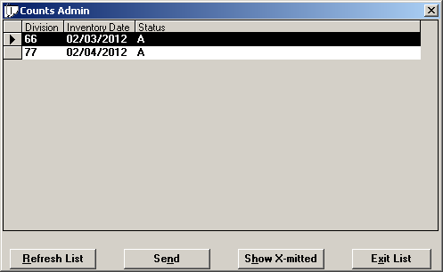

  - Database Details

select
division,
inventory_date,
status,
hdrid (not displayed)
from cnt_hdr
where status in (‘A’, ‘S’)
order by division, inventory_date, status;

- The “Send/Delete Entry” Button

When the highlighted row has a status of “A”, the button should display the title “Send”. If the status is “S”, the button should say “Reopen”.

  - Database Details for “Send” Button

Prior to updating the database, the program should ensure that all of the detail rows associated with the header have been finished.

select count(*)
from cnt_dtl
where hdrid = <selected header ID>
and status != “F”;

If any rows exist, the program should prevent the database update and instead display the message, “There are counts that are not finished.” Once the user has acknowledged the message, the program should return to the Counts Admin screen, and should highlight the previously-selected row.

If all the detail rows are finished, then the program can update the database.

begin work;

update cnt_hdr set
status = “S”,
status_date = TODAY
where status = “A”
and hdrid = <selected header ID>;

update cnt_dtl set
status = “S”,
status_date = TODAY
where status = “F”
and hdrid = <selected header ID>;

commit work;

  - Database Details for “Reopen” Button

begin work;

update cnt_hdr set
status = “A”,
status_date = TODAY
where status = “S”
and hdrid = <selected header ID>;

update cnt_dtl set
status = “F”,
status_date = TODAY
where status = “S”
and hdrid = <selected header ID>;

commit work;

- The “Show X-mitted” Button

This button allows the user to list transmitted counts. When clicked, the program should display the following dialog box:

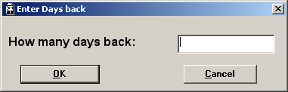

The program should allow the user to key in a value between 0 and 999. Once this number has been provided, the Counts Admin screen should display data based on the following SQL:

select
division,
inventory_date,
status,
hdrid (not displayed)
from cnt_hdr
where status = “X”
and inventory_date >= <TODAY – days-back value>
order by division, inventory_date, status;

If the SQL generates an empty result set, the program should display the message “No Extracted Counts Found in that Range”, instead of repopulating the Counts Admin window with the filtered data.

- The “Refresh List” Button

When the user presses the “Refresh List” button, the program should redraw the Counts Admin screen with the current data. If the display is currently in “show transmitted counts” mode, it should revert back to the original selection logic.

- Double-Clicking On A Row

If the program is in “show transmitted counts” mode, this action should be ignored.

If the program is using the original selection logic, the following screen should be displayed: (Please note the title of this window is also “Counts Admin”. It really should have a title saying something like “Counts Detail.”

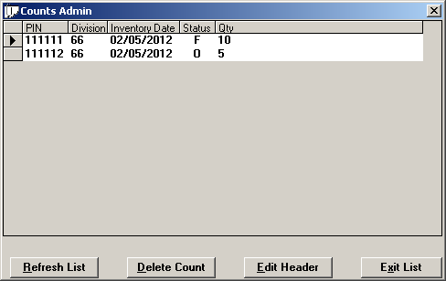

select
d.assoc_no,
h.division,
h.inventory_date,
h.status hdr_status, (not displayed)
d.status dtl_status,
sum(d.qty)
from cnt_hdr h, cnt_dtl d
where h.hdrid = d.hdrid
and h.hdrid = <selected header-ID>
group by d.assoc_no, h.division, h.inventory_date, hdr_status, dtl_status
order by d.assoc_no, h.division, h.inventory_date, hdr_status, dtl_status

  - “Delete Count” Button

If the highlighted row has a detail status of “F”, and the associated header status is “A”, the button should be enabled. Otherwise the button should be disabled.

If the user clicks on the “delete count” button, the program should ask the following question: “Are you sure you want to delete PIN nnnnnn, Division nn, Inventory Date mm/dd/yyyy?

If the user confirms, the program should do the following:

begin work;

delete from cnt_dtl
where hdrid = <selected header ID>
and assoc_no = <selected Assoc #>
and status = “F”;

select count(*)
from cnt_dtl
where hdrid = <selected header ID>;

If as a result of the delete statement the header record no longer has any detail records, the program should also delete it:

delete from cnt_hdr
where hdrid = <selected header ID>;

commit work;

  - “Edit Header” Button

If the highlighted row has a detail status of “F”, and the associated header status is “A”, the button should be enabled. Otherwise the button should be disabled. If the user clicks the button, the program should prompt for a new inventory date:

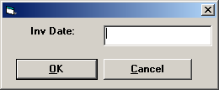

The keyed date must be in the format “MMDDYYYY”. Once the user provides a valid date, the program should check the header file and see if a target row exists.

select
min(hdrid) new_hdrid
from cnt_hdr
where inventory_date = <keyed date>
and division = <selected division>
and status = “A”;

    - If An Existing Row Is Found

If a row is found, the program should move all of the associated detail rows from the old header record to the new header record, then delete the old header record if necessary:

begin work;

update cnt_dtl set
hdrid = <new header ID>
where hdrid = <old header ID>
and assoc_no = <selected Assoc #>
and status = “F”;

select count(*)
from cnt_dtl
where hdrid = <old header ID>;

If as a result of the update statement the old header record no longer has any detail records, the program should also delete it:

delete from cnt_hdr
where hdrid = <old header ID>;

commit work;

The program should then refresh the data the Counts Detail window.

    - If An Existing Row Is Not Found

If a row is not found, the program should create a new header record.

insert into cnt_hdr (
hdrid,
division,
inventory_date,
count_start_date,
count_start_time,
status,
status_date,
last_modified_by,
transmit_date )
values (
0,
<selected division>,
<keyed date>,
TODAY,
CURRENT,
“A”,
TODAY,
<ID of associate logged into Launch Pad>,
NULL );

Then, move the associated records to the new header record.

begin work;

update cnt_dtl set
hdrid = <new header ID>
where hdrid = <old header ID>
and assoc_no = <selected Assoc #>
and status = “F”;

select count(*)
from cnt_dtl
where hdrid = <old header ID>;

If as a result of the update statement the old header record no longer has any detail records, the program should also delete it:

delete from cnt_hdr
where hdrid = <old header ID>;

commit work;

The program should then refresh the display for both the header and detail windows.

